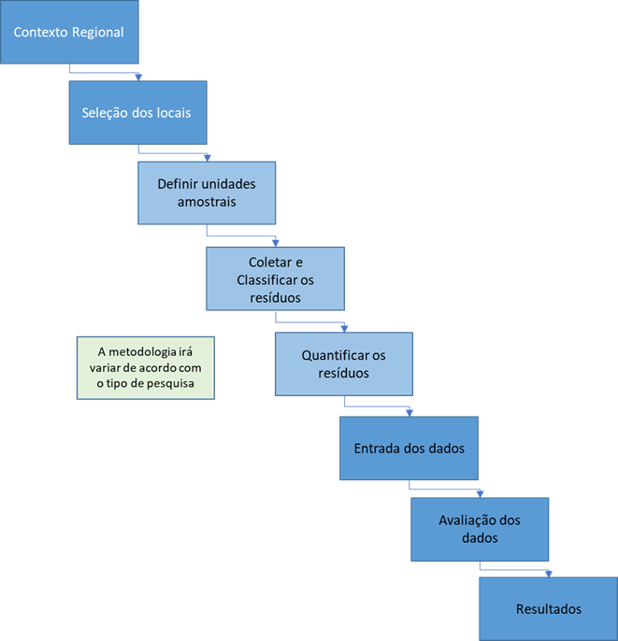

Regional Context

Selection of locations

Define sample units

Collect and Classify waste

Quantify waste

Data entry

Evaluation of data

Findings

The methodology will vary according to the type of research

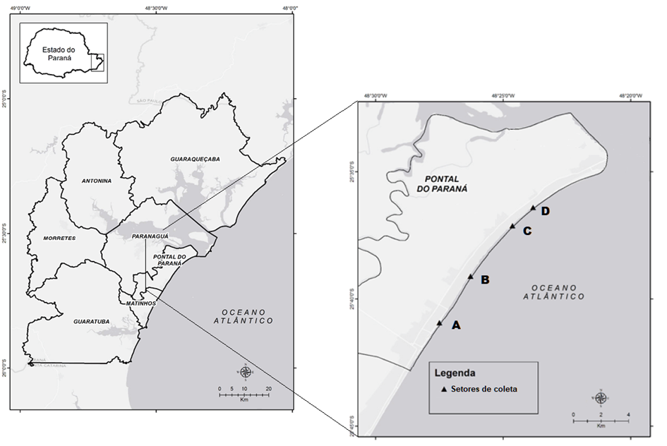

State of Paraná

Caption

Collection sectors

Atlantic Ocean

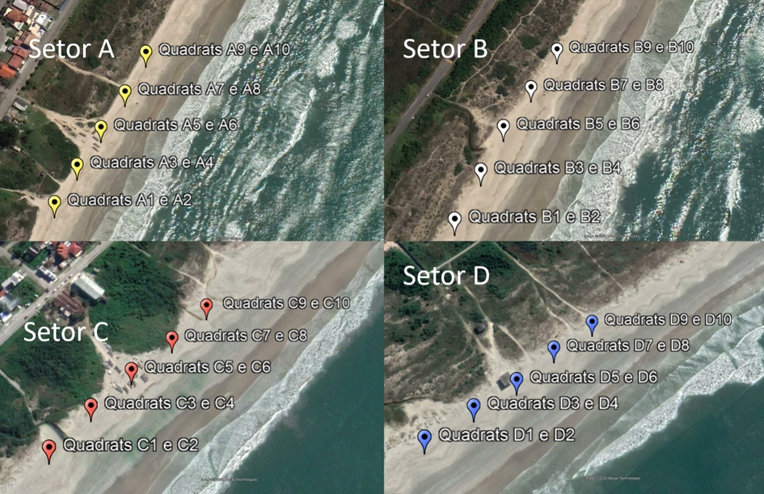

Sector

Quadrats

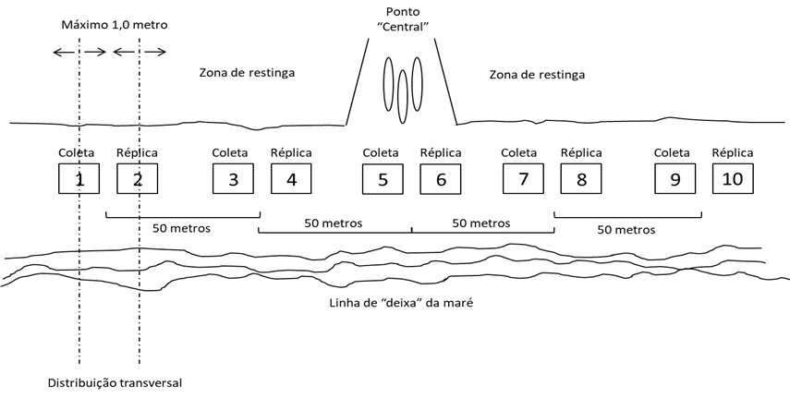

Maximum

Meter

Restinga zone

Center point

Restinga zone

Collection

Replica

Line of "leaves" of tide

Cross-sectional distribution

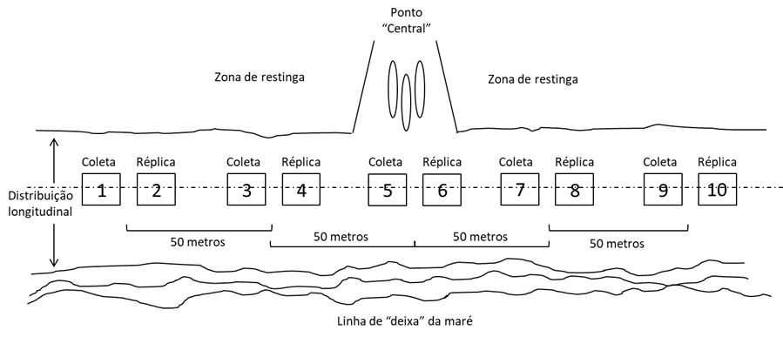

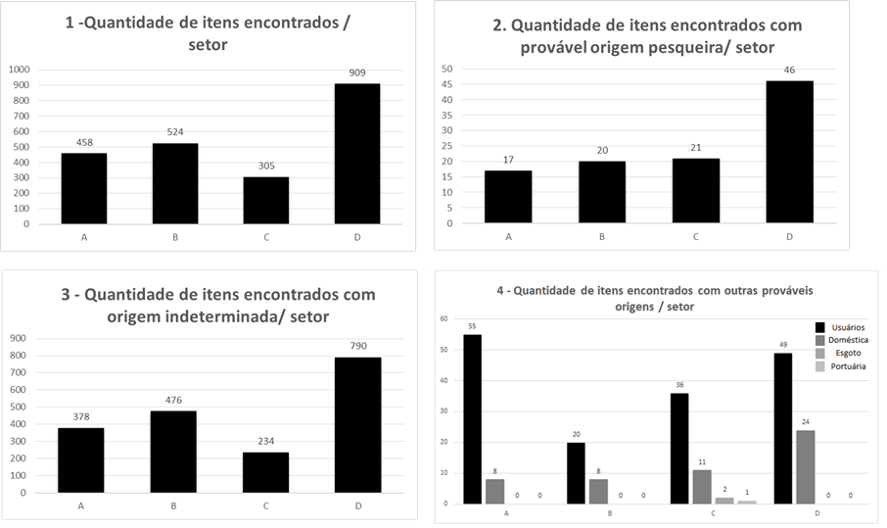

Number of items found /sector

Number of items found with probable fishing origin/ sector

Number of items found with indeterminate origin / sector

Number of items found with other probable sources/sector

Users

Domestic

Sewage

Port

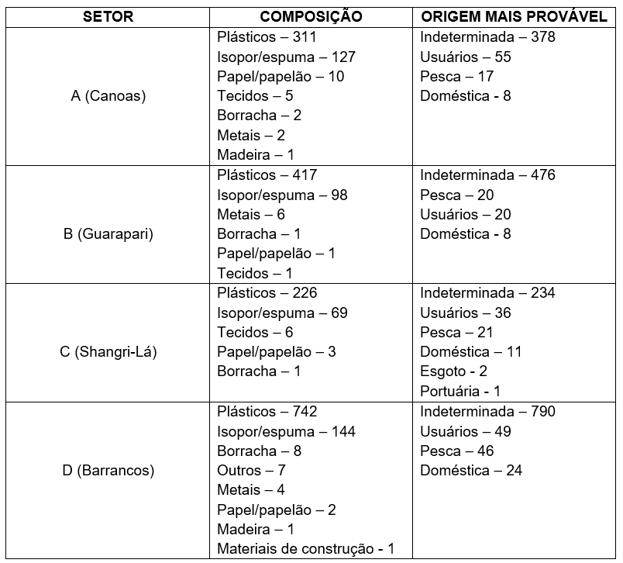

Sector / Composition / Most Likely Origin

Indeterminate - User - Fishing - Domestica

A(Canoes)

Plastic

Styrofoam/Foam

Paper / Cardboard

Tissues

Rubber

Brass

Wood

Other

Building materials

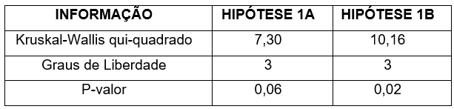

Information / hypothesis 1A / Hypothesis 1B

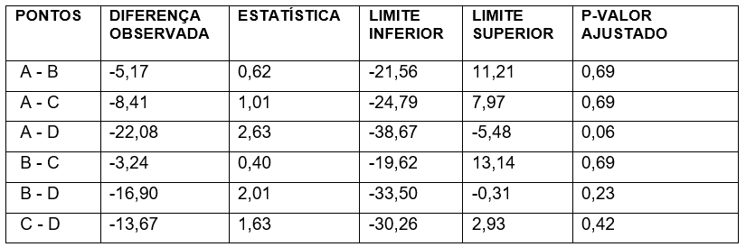

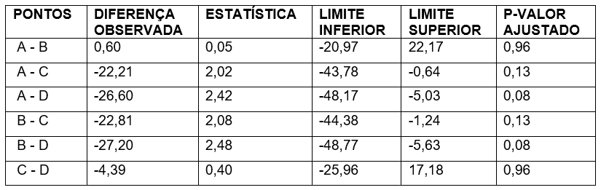

Points / Observed difference / Statistics / Lower limit / Upper limit / P-Adjusted value

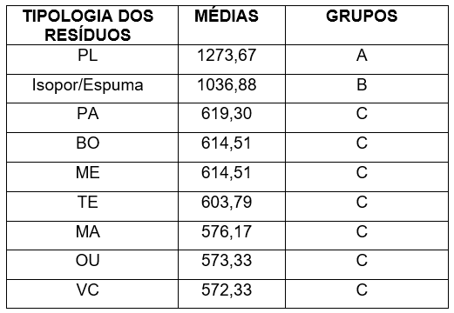

Typology of waste / Averages / Groups

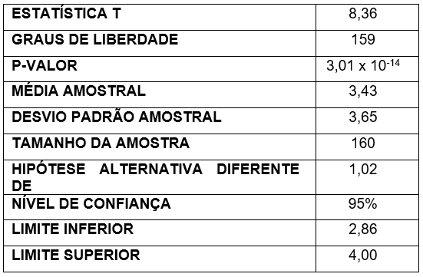

T Statistics

Degrees of freedom

P-Value

Sample mean

Sample standard deviation

Sample size

Alternative hypothesis other than

Confidence level

Lower limit

Upper limit

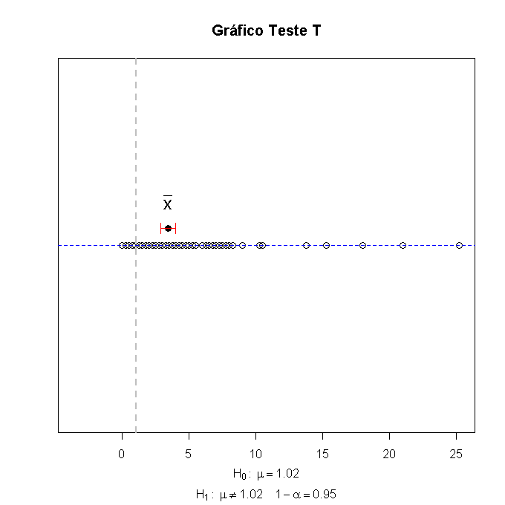

Test T Chart

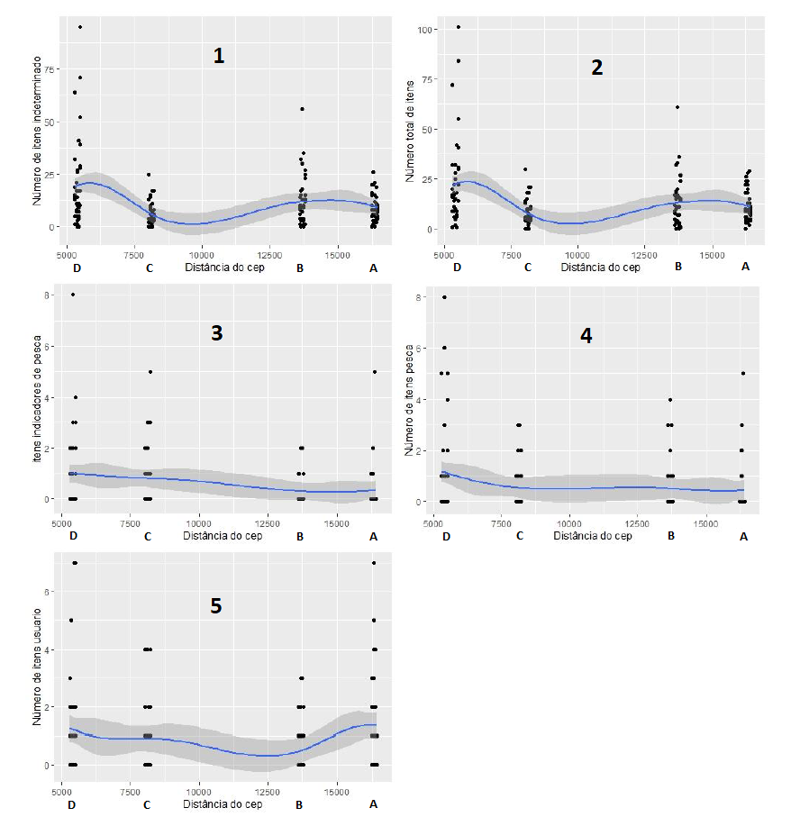

Number of items after

Total number of items

Fishing indicator items

Number of fishing items

Number of items used

Zip code distance